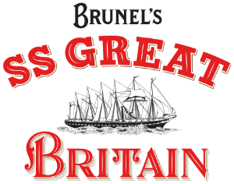

Work Experience at

Brunel’s SS Great Britain

Many thanks for your interest in taking part in the Work Experience Programme at the SS Great Britain. Please find more information below about the SS Great Britain, what you could be doing during the week and what you might gain from the week.

Brunel’s SS Great Britain

The SS Great Britain is the world’s first great ocean liner and the most innovative steam ship of her time. The ship was built in Bristol and launched in 1843, travelling to New York and later taking passengers over to Australia during the Gold Rush.

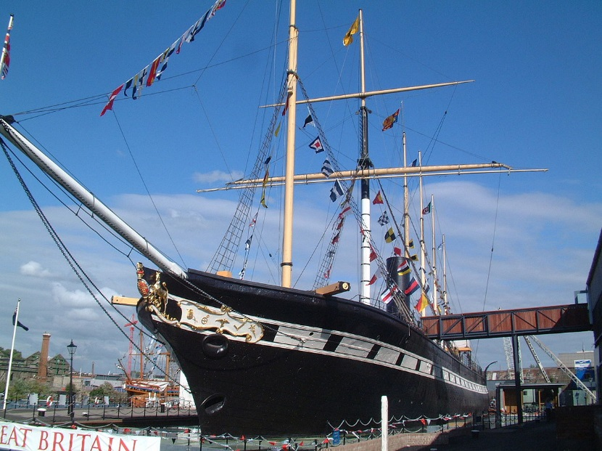

Today we are an award-winning museum in the centre of Bristol (www.ssgreatbritain.org). We are also Bristol’s no. 1 visitor attraction (according to TripAdvisor). Visitors can travel back in time and explore the ship as she was in the Victorian era (including sights, sounds and smells!) They can also find out more about the passengers who travelled on board the ship. In addition, we also have a library and archive (collection of important historical objects). We will also be opening a brand-new, national museum in March 2018 which will explore Isambard Kingdom Brunel.

It’s an exciting time to join the SS Great Britain team with lots going on. You will have the opportunity to explore what goes in to delivering a world-class visitor experience. How do we attract new people to visit the ship? How do we market our events to people in Bristol, the UK and all over the world? What makes a great half-term activity for families? How do we make money, so we can preserve the ship for the future? What stories about passengers and crew can we discover in our library which will be interesting for our visitors?

The Work Experience week

We have put together a week which will give you experience working across the organisation. In addition to exploring what it’s like to work in a museum and visitor attraction, you will also gain experience with our marketing, finance, events, interpretation and conservation teams. You will find out what different people do in their jobs every day (and see if any of these roles appeal to you), complete team challenges and have the opportunity to contribute ideas and complete an interesting, valuable project for the SS Great Britain Trust.

You will be working with three other students who will be part of our work experience programme this year.

A few examples of activities you might be doing are:

- A behind the scenes tour of the ship with our interpretation team, learning about how the sound system, interactives and even smells work!
- A workshop and group challenge with our marketing team.
- Researching passenger stories in our archive and library.
- Planning a budget for a new activity or event, with the support of our finance team.
- Working on a team project and presenting back to senior staff.

About you

- You might already be interested in history, tourism, or the arts.
- You might want to explore what working in a museum, or visitor attraction is really like.
- You might enjoy planning events, coming up with new ideas or communicating with other people.
- You might want to explore a range of different jobs and see which ones appeal to you.
- You might want to develop your communication and teamwork skills during the week.

If this opportunity interests, you can complete and return the attached application form and parent/ guardian consent letter to the SS Great Britain.

SS Great Britain Trust
www.ssgreatbritain.org

Work Experience Application Form

PLEASE FILL IN ALL SECTIONS OF THIS FORM
If you don’t we might not be able to consider you for a place

CONTACT DETAILS
Name | Click here to enter text.
Your school | Click here to enter text.

ABOUT YOU
What do you know already about Brunel’s SS Great Britain? Please let us know if you have visited us before. | Click here to enter text.
Why would you like to do a work experience placement at the SS Great Britain? | Click here to enter text.
What skills, qualities and interests would you bring to the SS Great Britain team? | Click here to enter text.

Please return this form, with the parent/ guardian consent form, to Matilda Wallis, The SS Great Britain Trust, The Great Western Dockyard, Bristol, BS1 6TY

