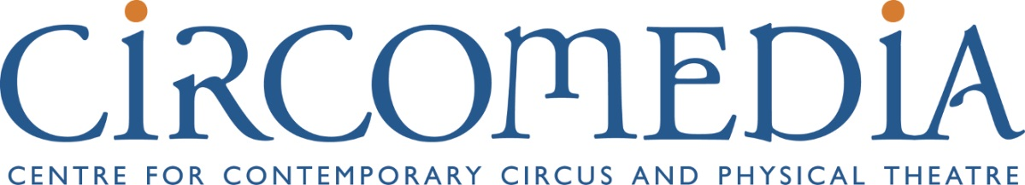

Work Experience Application Form

Dates for this year’s placement are still to be confirmed but likely to be June/July 2018

Please fill in all sections. If you don’t, we may not be able to consider you for a placement.

Personal details:
Emergency contact name:
School Contact (e.g. form tutor, work experience co-ordinator:
School:

Email address:
Home address:
Date of birth:
Name:

Emergency contact phone number:

Please detail any specific requirements (e.g. adaptions, access requirements etc)

Please tell us more about yourself
1. Please tell us why you are interested in a Work Experience placement at Circomedia.

2. What would you like to get out of the placement? What do you hope to learn, achieve and experience during your time with Circomedia?

3. What are your personal interests?

Please return your completed form to Ben Tansey via email ben@circomedia.com
or by post Circomedia, The Kingswood Estate, Britannia Rd, Kingswood, Bristol, BS15 8DB

